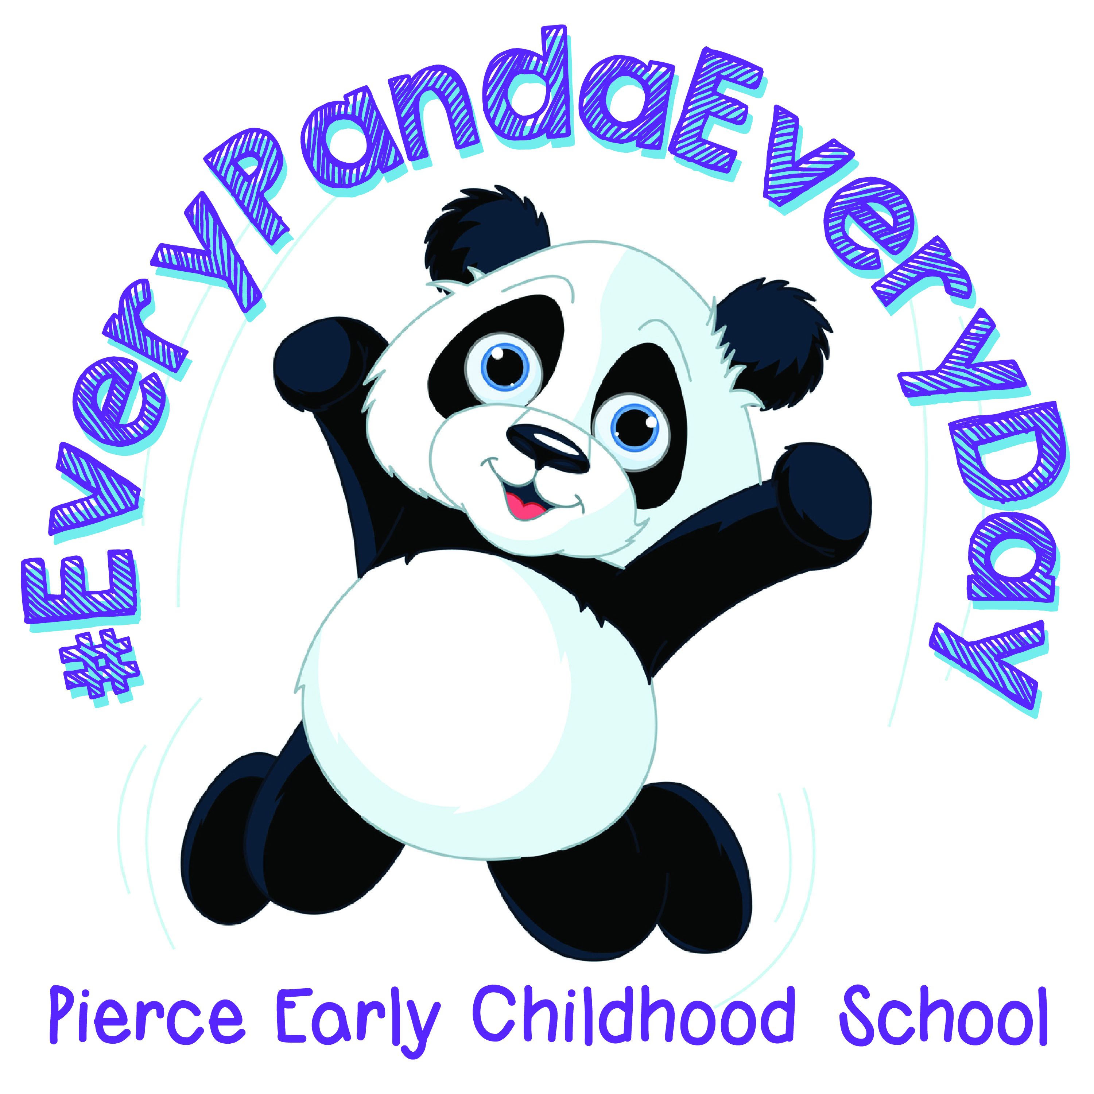
2023-2024 Parent and Family School Compact

Pierce Early Childhood School and the parents of the students participating in activities, services, and programs funded by Title I, Part A of the Elementary and Secondary Education Act (ESEA) (participating children), agree that this compact outlines how the parents, the entire school staff, and the students will share the responsibility for improved student academic achievement and the means by which the school and parents will build and develop a partnership that will help children achieve the state’s high standards. This family-school compact is in effect during the 2023-2024 school year.
School Responsibilities
Pierce Early Childhood School will:
● Be a positive, contributing member of our collaborative team.
● Teachers will be part of weekly collaborative planning.
● Teachers will implement and follow the districts assessment calendar (including state and local assessments).
○ Use evidence of student learning to inform and improve our practice and to better meet the needs of individual students.
● Engage in meaningful, job-embedded staff development to enhance our professional skills.
● Ongoing campus and district staff developments will be provided to our faculty to improve academic instruction.
● Utilize a variety of instructional strategies to promote success for all students.
● Teachers will plan lessons according to the district’s adopted curriculum.
○ Lessons will be based on state standards and ongoing assessment results.
● Initiate individual and small group instructional practices to provide additional learning time for all students.
● Teachers will support students in the classroom (ie: small group, RTI groups).
● Communicate and provide parents with resources, strategies, and information to help students succeed.
● Conferences will be held on campus designated dates (conferences can be requested by the teacher and/or parent at any time).
● Staff will respond to phone calls, emails, notes, SeeSaw posts, etc. within 24 hours.

Parent Responsibilities
We, as parents, will support our children’s learning by:
● Monitoring daily attendance and tardies.
● Staying informed about my child’s education and communicating with the school by checking SeeSaw, listening to the school messenger, promptly reading all notices from the school or the school district either received by my child or by mail/email and responding, as appropriate.

● Monitoring the amount of television (screen time) my child uses.
● Taking the initiative to seek the best educational opportunities for my child.
● Actively volunteering at Pierce Early Childhood School.
● Participating, as appropriate, in decisions relating to my child’s education.
● Serving, to the extent possible, on policy advisory groups such as the following: the Title I, Part A parent representative on the school’s School Improvement Team, the District-wide Policy Advisory Council, and/or the School Parent Teacher Organization.
● Respecting the teachers and supporting the Pierce ECS staff as partners in the education of my child.
● Utilizing two-way communication between myself and the Pierce ECS staff on the instruction, achievement and conduct of my child.

Please share with your child the student responsibilities listed below.
Student Responsibilities
We, as students, will share the responsibility to improve our academic achievement and achieve the state’s high standards.

Specifically, I will:
● Read or listen to reading at least 10-30 minutes (depending on child’s grade level) every day outside of school time.
● Give my parents all notices and information received by me from my school every day.
● Let my teacher and family know if I need help.
● Respect teachers, staff members and all students.
● Have a positive attitude.
● Follow rules and expectations.
● Adhere to the appropriate use of technology.
● Always try my best!

Opportunities for Parents
Parents are encouraged to volunteer at the school and participate in events offered by Pierce ECS School.

I have read and agree with the Pierce ECS parent compact.

Teacher Name: ________________________________________________________________

Principal Signature Date

______________________________________ _________________________________

Parent Signature Date

______________________________________ _________________________________

Student Signature
(Please help your child write his/her name) Date

______________________________________ __________________________________

